**South Carolina Association of Ministers’ Wives and Ministers’ Widows**

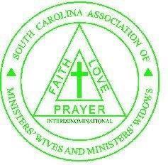Mrs. Teresa Thurmond, State President

80th ANNUAL STATE CONFERENCE

**April 11th-12th, 2025**

Hosted by the Spartanburg County Alliance of Ministers’ Wives and Ministers’ Widows

Rev. Audrey V. Hailstock, Local President

**PLEASE PRINT**.

|  |  |
| --- | --- |
| Name of Local organization |  |
| Name of Local President |  |
| Your Name |  |
| Your Mailing Street Address |  |
| City, State, Zip Code |  |
| Your Email Address |  |
| Telephone Number (Home and Cell) |  |
| Your Husband’s / Guest’s name |  |
| Member Registration | $25 |
| Husband Registration | $15 |
| Souvenir Book | $20 |
| T-shirt (**Your size: _______)** | (S-XL $15) (2XL-4XL $18) ______ |
|  | $100 |
| Luncheon Tickets $40 | Please see local president. |
| **Total** | ____________ |
| **Must register on or before 3/1/2025** |  |

Please mail this form with your check made payable to **Spartanburg County Alliance MWMW** to

Spartanburg County Alliance MWMW.

C/O Mrs. Carol Avent Rector

512 Edgevale Drive

Boiling Springs, SC 29316

**\*\*\*LATE FEE of $15 if postmarked after FEBRUARY 27, 2025.**